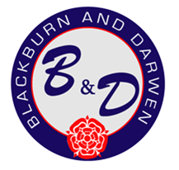
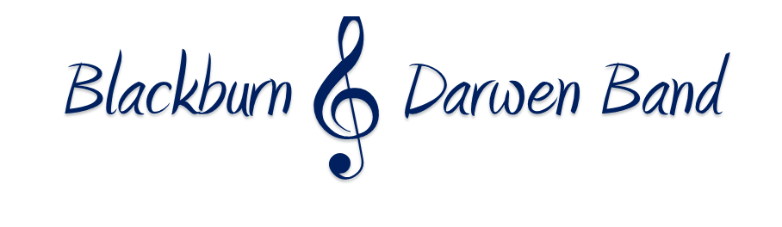

Kindly supported by

March & Hymn Contest Application
Sunday 9th June 2024

Name of Band
National Grading of Band
Musical Director of Band
Contest Secretary Name & Contact Info, inc Tel
Email
Payment Method

£60 entry fee (Refunded if contest is cancelled)
Bank Transfer payments to be made to Blackburn & Darwen Band, Sort code 30-90-87 Account No 00652287
Cheques to be made payable to Blackburn & Darwen Band
Closing Date 26th May 2024
Application forms can be sent via email to blackburnanddarwenband@gmail.com or via post to Sue Speakman, 3 Meadow Terrace, The Meadows, Darwen, Lancs BB3 0SP

